**EMPLOYEE MANAGEMENT SYSTEM**

(By Ashish Kumar, 206634)

**INTRODUCTION**

1. Console-based Application: The project is a command-line-based Employee Management System that allows admins to manage employee data through a simple interface built with Python.

2. Admin Authentication: It features an admin registration and login system to secure access. Admin credentials are stored in a MySQL database, and the login system ensures that only registered users can access employee data.

3. CRUD Operations: The system enables admins to perform Create, Read, Update, and Delete (CRUD) operations on employee records. These include adding new employees, viewing employee details, updating specific information (like salary or department), and deleting employee records.

4. MySQL Database Integration: All employee data and admin credentials are stored in a MySQL database, ensuring data persistence. The database contains tables for employee details (name, email, age, salary, department) and admin information (username, password, name).

5. Structured Code Design: The project is designed with a modular approach, separating functionalities like authentication, employee management, and database connection, making the code organized and easy to maintain.

COMPLETE CODE

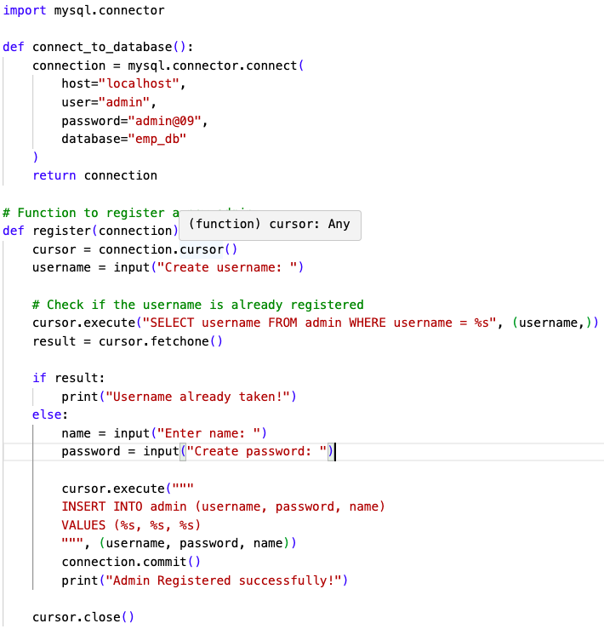

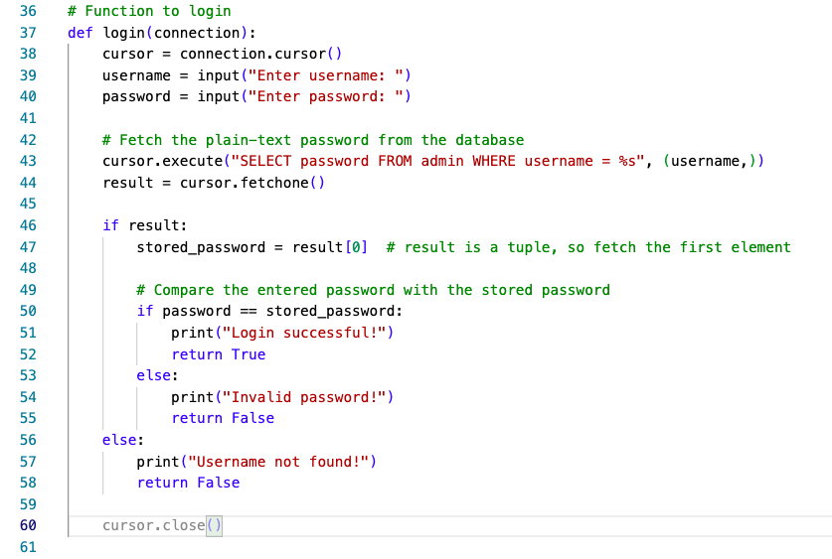

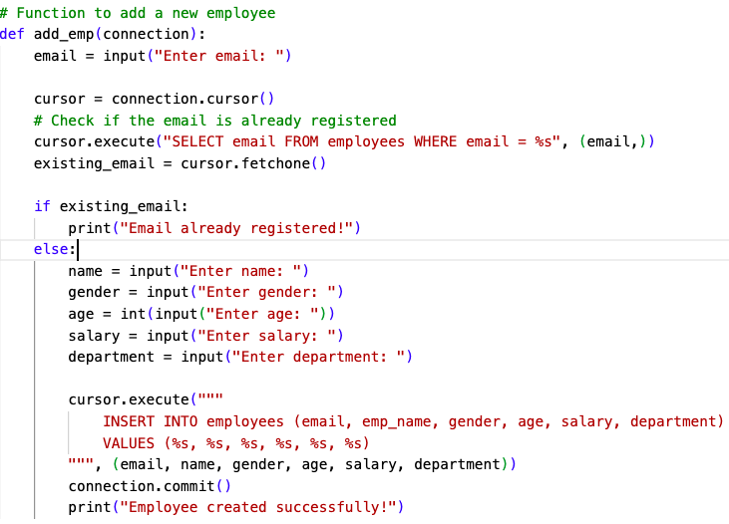

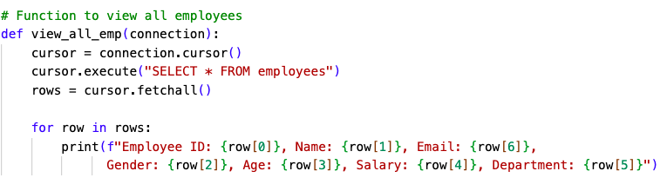

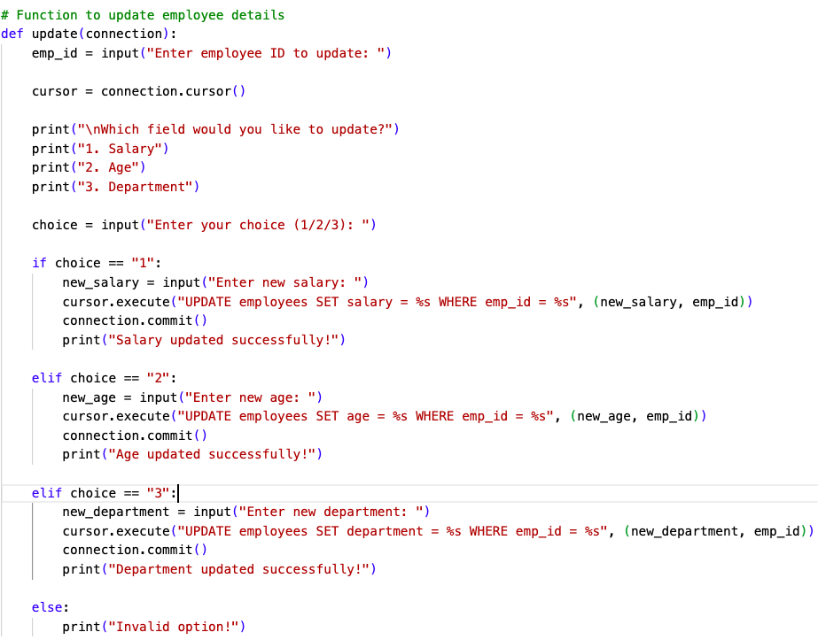

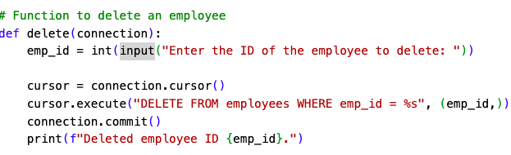

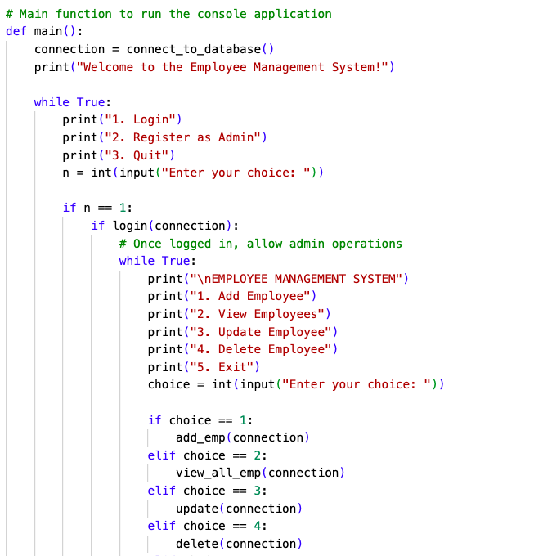

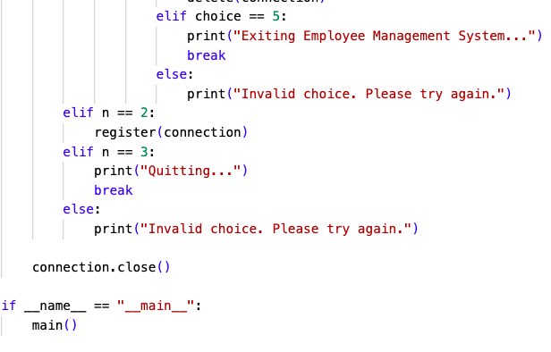

OUTPUTS:

